The DOCUMENT OBJECT MODEL (DOM) 2:

PULL-DOWN MENUS:

1: PART A: THE RESOURCES FOR THIS SESSION: 2
2: Creating an Array of Menus: 3
3: Link menus.js to holmes.htm: 3
4: PART B: DISPLAYING THE PULL-DOWN MENUS (PRE-ANIMATION): 4
5: Adding the Event Handlers to the Menus: 4
6: Keeping Track of Which Menu is Currently Open: 4
7: The changeMenu() Function: 5
8: The closeOldMenu() Function: 6
9: Clicking Outside the Pull-down Menu Titles: Fixing the Problem: 7
Verify that when you click on the top-left logo, or the main text or the links, the active pull-down menu now closes. 7
10: Displaying a Menu When the Mouse is Over a Pull-Down Menu Title: 8
11: PART C: ANIMATING A PULL-DOWN MENU: 9

1: PART A: THE RESOURCES FOR THIS SESSION:
The website holmestxt.htm is a Sherlock Holmes fan website. It has a JavaScript file menustxt.js, and a stylesheet shblogtxt.css, as well as two image files. We will create pull-down menus to become familiar with using the DOM at an introductory level. The menus are already there, ready to go...we just have to add the JavaScript to make them dynamic!

Save the above 3 files with the following names:
- holmes.htm
- shblog.css
- menus.js

Open holmes.htm. There are 6 pull-down menu titles, each of which displays a particular pull-down menu:
- “The Adventures of Sherlock Holmes” (<div id="menu1" class="menu">);
- “The Memoirs of Sherlock Holmes” (<div id="menu2" class="menu">);
- “The Return of Sherlock Holmes” (<div id="menu3" class="menu">);
- “The Case Book of Sherlock Holmes” (<div id="menu4" class="menu">);
- “His Last Bow” (<div id="menu5" class="menu">);
- “The Novels” (<div id="menu6" class="menu">).
At the moment, if you click on them, they are neither visible, nor do they drop down.

The pull-down menus are unordered lists (<ul>). They have the following code in holmes.htm:
- <div id="menu1List" class="menuList">;
- <div id="menu2List" class="menuList">;
- <div id="menu3List" class="menuList">;
- <div id="menu4List" class="menuList">;
- <div id="menu5List" class="menuList">;
- <div id="menu6List" class="menuList">.

Notice the close connection between a pull-down menu title and its associated pull-down menu.

Open shblog.css. You should see that the .menuList class style has display: none. Change this to display: block and refresh holmes.htm. You should see the following:
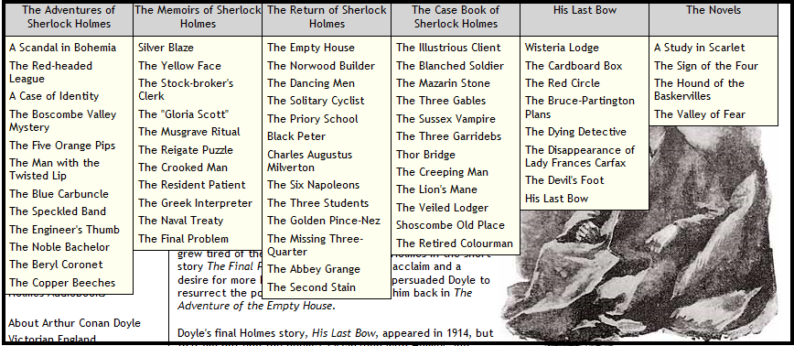
Reset back to display: none, and refresh the webpage to confirm that the pull-down menus have disappeared.

2: Creating an Array of Menus:
Open menus.js and add the following code. This will create two arrays: allElems stores information on all tags in the webpage; menus stores information on any tag that has class=”menu”. A for loop goes through all of the allElems elements and puts (or pushes) any tag that has class=”menu” into a new element at the end of the menus array.
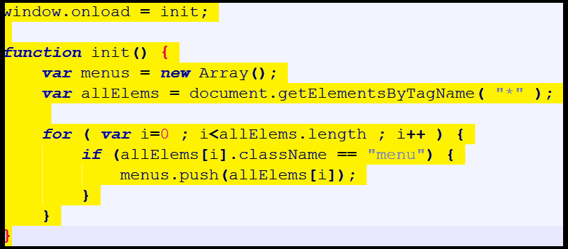

Why do we need to add this code? It makes it easier to code the event handling (see section after next). This won’t make any difference to displaying holmes.htm at present.

3: Link menus.js to holmes.htm:
You know what to do here!

4: PART B: DISPLAYING THE PULL-DOWN MENUS (PRE-ANIMATION):

5: Adding the Event Handlers to the Menus:

Add the following code to init() in menus.js:
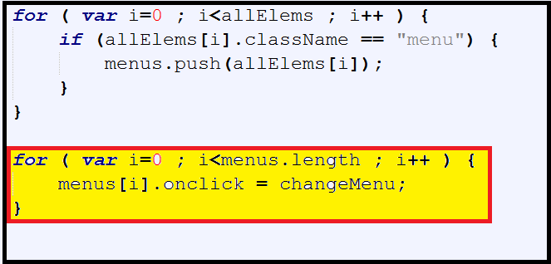
So...if we click on any of the webpage objects which have class=”menu”, we call the function changeMenu().

6: Keeping Track of Which Menu is Currently Open:

Before we add the function changeMenu(), we will need to keep track of which menu is open. We add the following variable outside of init(), so it has global scope: thus, changeMenu()can use it. Add the following code to menus.js:
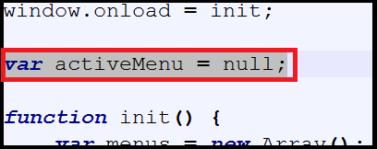
The variable activeMenu is initially set at null, as when the webpage loads, no pull-down menu is active.

7: The changeMenu() Function:
If we want to change pull-down menu, we need to do the following:
- Make sure that the currently open pull-down menu closes (we will develop code for this in a separate function later);
- Find out which pull-down menu title has been clicked;
- Display that particular pull-down menu as a block (as seen earlier in section 1).

Remember, from section 1, that the ids for these 6 pull-down menu titles (i.e. the bit we can click on) are “menu1” to “menu6”. Remember, too, that the pull-down menu ids are closely connected to the pull-down menu title ids.

Depending on which one we click on, the appropriate pull-down menu should display (i.e. “menu1List” for “menu1”, etc.)

Add the following code into menus.js:
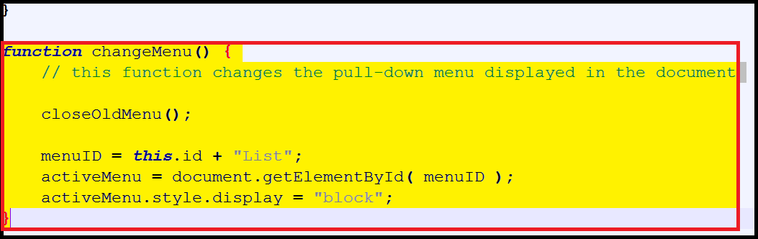
How does it work?
- The variable menuID takes the id of the pull-down menu title that has been clicked (i.e. we use “this”);
- “List” is appended to whatever is in menuID. e.g. if the “menu2” pull-down menu title had been pressed, menuID now stores “menu2List”, which is the name of one of the pull-down menus;
- activeMenu then stores the details of the pull-down menu which should be displayed;
- The appropriate pull-down menu is then displayed by setting the display to block [overwriting display: none].

You might be asking: why do we need activeMenu here, rather than just menuID?
- menuID is just a string, whereas activeMenu holds all the information about the string that is in menuID;
- we need activeMenu when we come to close the previously-chosen pull-down menu (see next section).

this refers to the currently-active object in the web browser.

8: The closeOldMenu() Function:
- When the webpage loads, activeMenu contains the value “null”, which means that no pull-down menu has been chosen.
- If a pull-down menu had already been chosen, then we need to close it before we display the newly-chosen one. In JavaScript, we can simply write if (activeMenu): i.e. if a pull-down menu had previously been chosen ... activeMenu would not contain “null”.
- When we close this old pull-down menu, we then need to reset activeMenu to “null”, so it can be overwritten by the changeMenu() function.

Add the following code to menus.js:
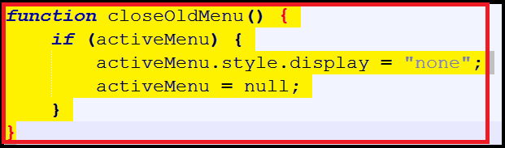

Display holmes.htm. You should see something like the following:
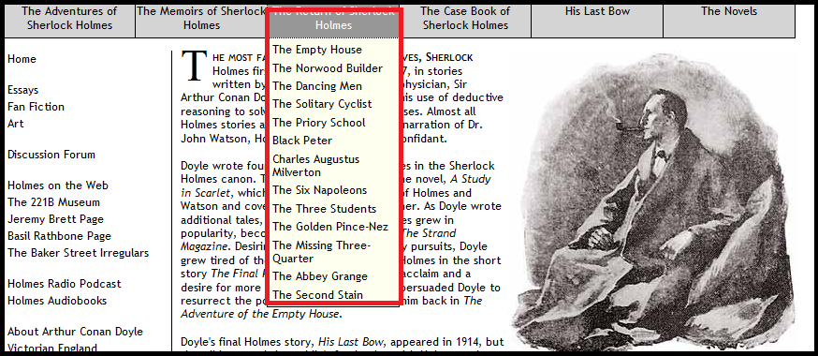
Verify that when you click on a new pull-down menu title, the previous one closes.

9: Clicking Outside the Pull-down Menu Titles: Fixing the Problem:
Notice that if you click on the top-left logo, or the main text or the links, the active pull-down menu doesn’t close. This needs to be fixed. Add the following code to the init() function:
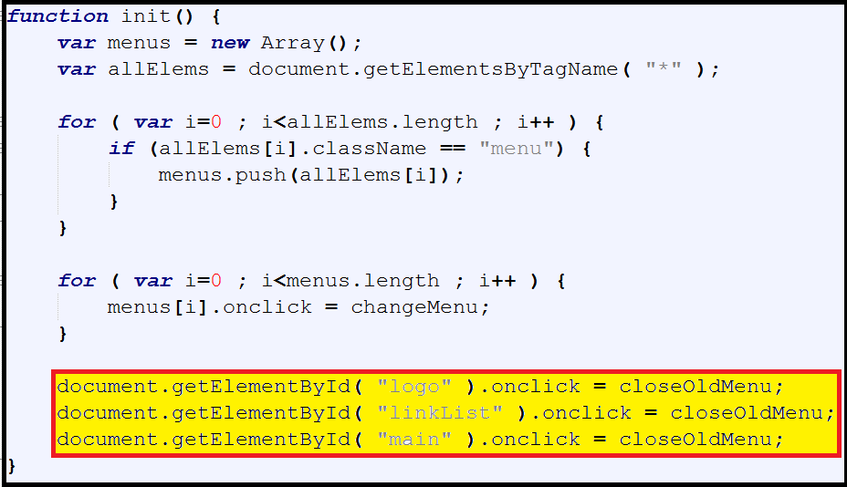
Verify that when you click on the top-left logo, or the main text or the links, the active pull-down menu now closes.

10: Displaying a Menu When the Mouse is Over a Pull-Down Menu Title:
We use the onmouseover event. Add the following code to menus.js:
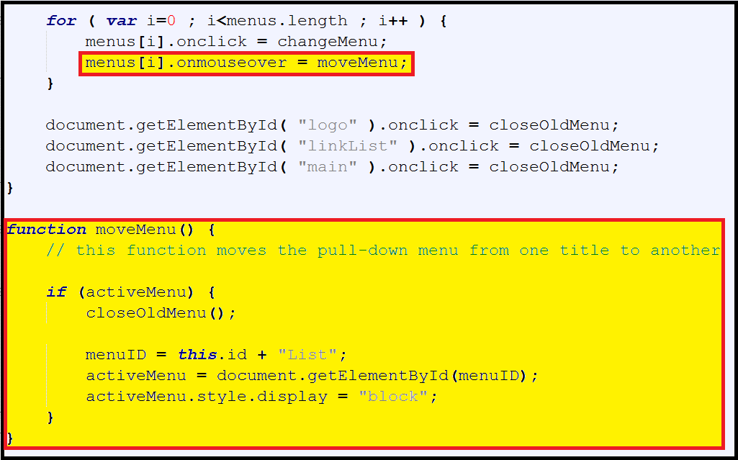

How does it work?
- We need to call moveMenu() if there is an onmouseover event. This has to be done in init().
- Note that moveMenu() is almost identical to changeMenu(), except that we need to add the enveloping if statement.
- In other words, unless you have already clicked to make a pull-down menu active, the onmouseover event will not work.

Verify that holmes.htm works as required.

11: PART C: ANIMATING A PULL-DOWN MENU:
We will animate the pull-down menu so that it appears to ‘unroll’ slowly (but not so slowly as to cause impatience!). This is achieved using the clip style. The syntax for clip is:
clip: rect(top, right, bottom, left)

To ‘unroll’ a pull-down menu, we need only change the “bottom” property of the clip style.

QUESTION:
Suppose you needed to create a “pull-across” menu, which should be on the left-hand-side of the webpage, so that it would unroll to the right. Which clip property would be changing?

Certain issues arise:
- We have to decide how fast this will happen:
  - We need a variable (timeID) to regulate how often the menu is unrolled before it is fully unrolled;
  - We need a variable (clipHeight) to regulate how much of the menu is unrolled each time the function rollDown() is run (none of the menus is more than 400px in height when fully unrolled);
- The function rollDown() does the unrolling;
- We need to call rollDown() repeatedly in both moveMenu() and changeMenu():
  - We use setInterval(“function name”, how often in milliseconds) to repeatedly run this;
  - We also use clearInterval() when the pull-down menu is fully unrolled to stop running the function.

In the following screenshot, we add 5 pieces of code (numbered in the screenshot):
- clip shows only part of the object. By setting the “bottom” property of clip to 0, we ensure that the object is invisible at the start. This has to be done whenever we display a pull-down menu (i.e. in moveMenu() and changeMenu()).
- New global variables needed:
  - clipHeight will be used to increase the clip height, bit by bit.
  - timeID allows the function rollDown() to be called repeatedly.
- The function rollDown():
  - increases the height of the clip in 3-pixel increments until the entire pull-down menu is visible (the clip height is 400px).
  - If the entire object is visible, we have to:
    - stop running the function, and
    - reset clipHeight back to 0 for whenever it will be next used.
- Where rollDown() is called from repeatedly. Note that it is called every millisecond (the ‘1’).
- Finally, if we close a menu before it has fully unrolled, it shouldn’t keep unrolling, so we need to stop it in closeOldMenu().

Add the following code to menus.js:
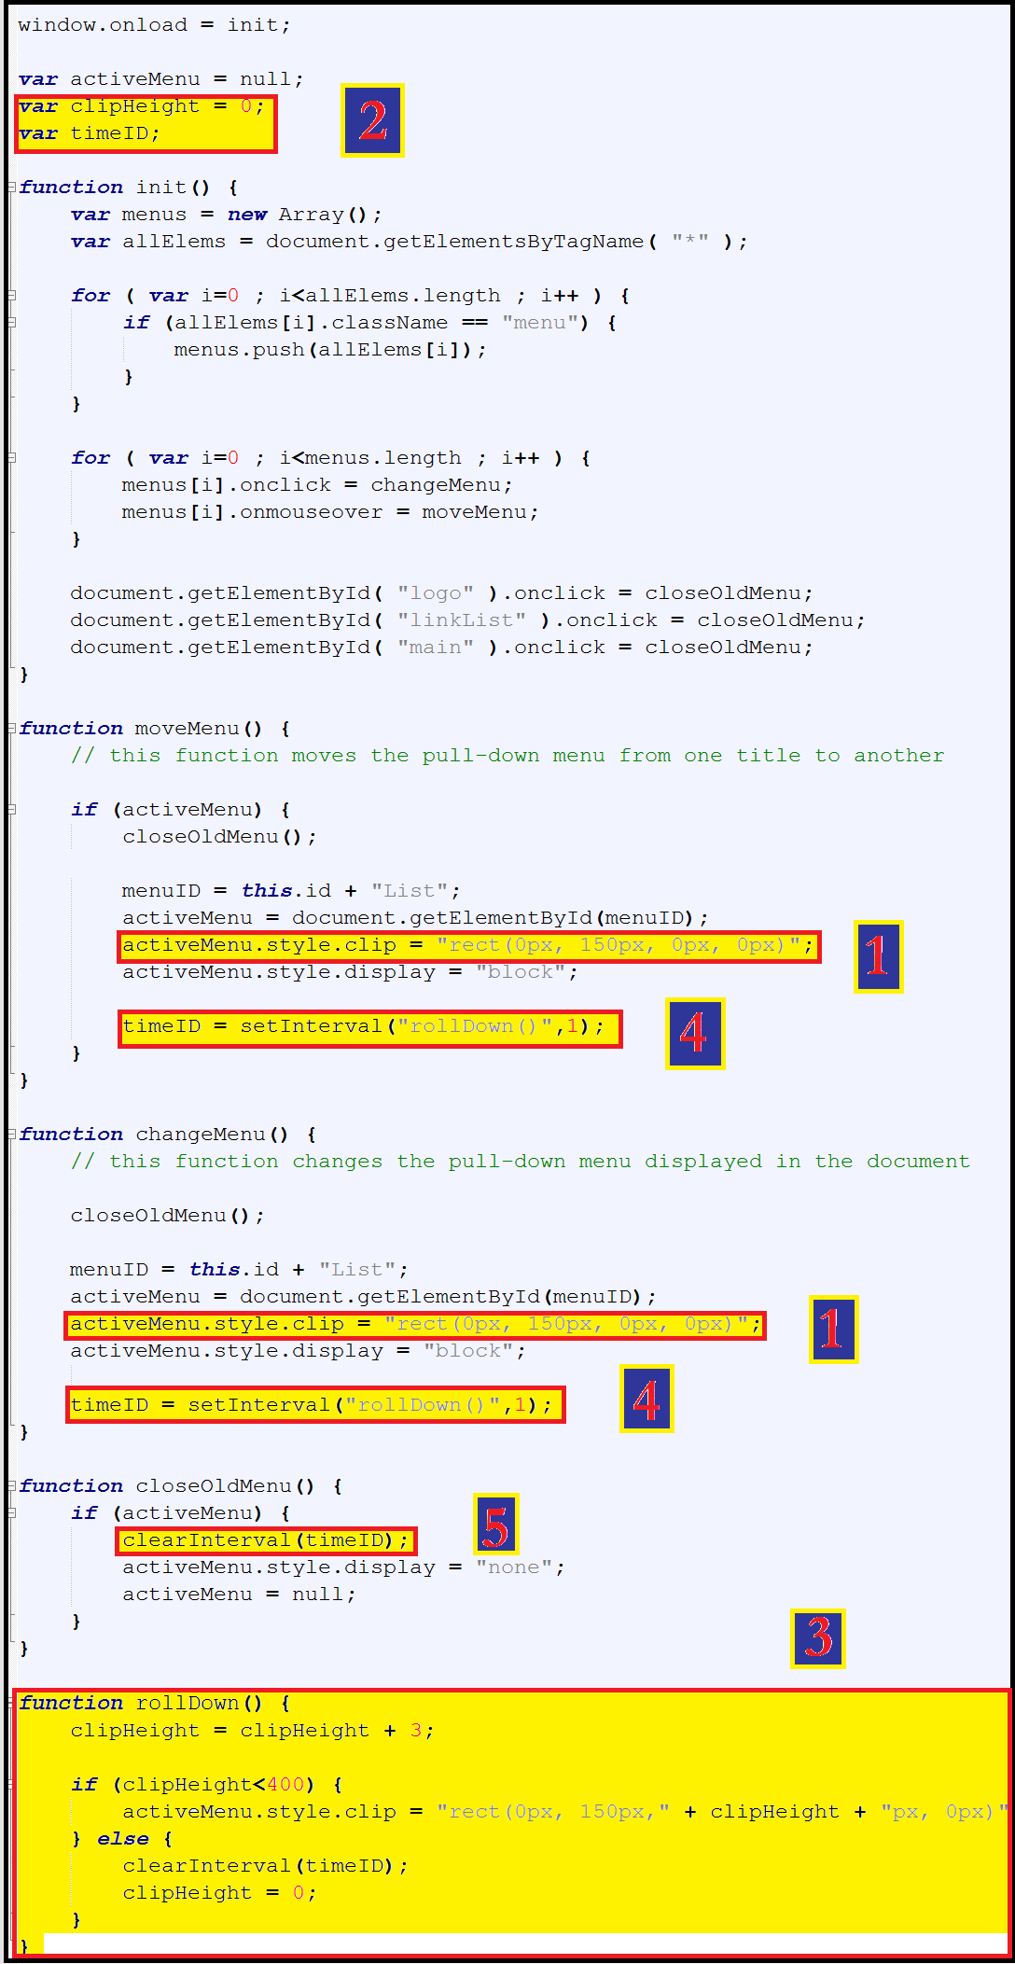
Verify that holmes.htm works properly.

